McDonnald Douglas- Max Tek
AH-64 Apache Pegasus

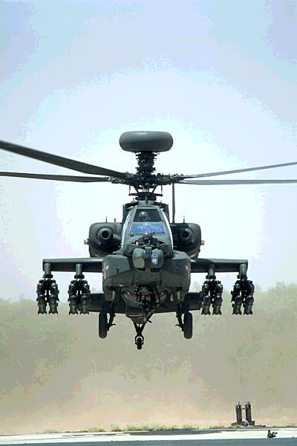
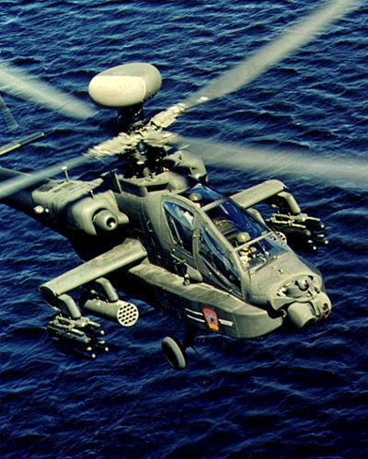

The New upgrade for the traditional AH-64 Apache is the new Apache Pegasus. Like the LongBow upgrade in the late 90's this is long overdue. It was sparked because of losses during the EuroWars and in other minor conflicts that have occured since then. The new Upgrade includes the introduction of Smart Materials that reduce the noise output of the helicopter, advanced electronics like ED and ECD, Limited Use of Radar Absorbant materials and Thermal Baffling, it also includes CMC's for increased Surviability. The Pegasus upgrade makes the Apache the first helicopter to receive the Advanced Passenger Protection System specially designed for use in helicopters.

Handling | Speed | Accel | Body | Armour | Sig
5 | 400 | 40 | 5 | 15 | 6(8)
Autonav | Pilot | Sensor | Cargo | Load
2 | NA | 8 | 6 | 2000
Seating | 1e+1e |  |  | Setup/Breakdown |  |  | N/A
Entry | 1 |  |  | Landing/Takeoff |  |  | VTOL
Fuel | Jet Turbine (3,000 Liters) |  |  | Economy |  |  | .3km/liter
DP Cost | NA |  |  | Cost |  |  | 18,000,000
Template | Attack Helicopter |  |  | Reference |  |  | The Shop
Features | Smart Materials  APPS  CMC 3  Datajack Port  Rigger Adaptation  Thermal Baffles(factored in)  RAM 1(factored in)  External Fixed Hardpoint with Shredder HMG and 1000 Depleted Uranium Rounds  Gunnery Recoil Adjusters: 9  4 External Missle Mounts  ECM: 7  ECCM: 7  ED: 4  ECD: 3

Typical Armarment:
On the 4 External Turrets are usually loaded with special Hardpoints that hold 4 Hellfire II missles per mount. In other words these Missle Mounts hold 4 missles each, the special hardpoint modification costs 5k¥ and takes the same amount of time as putting a normal missle on.
This modification is shown on the top picture.

